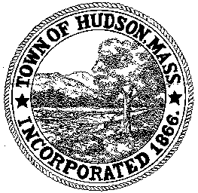

CONSERVATION COMMISSION
78 Main Street, Hudson, MA 01749
(978) 568-2020

Paul Byrne, Chairman W. Minot Wood, Vice Chairman David Esteves, Member

Terrence Joyce, Member Leif Longtine, Member Joseph Rodrigues, Member Al Tashian, Member

Agenda
May 21, 2009 7:00 P.M.

- Preliminaries
  - Open Meeting
  - Roll Call
1.3 Additions or Deletions to the agenda

2.0 Hearings and Appointments
2.1 Highland Commons
Amendment to Order of Conditions DEP 190-481

2.2 Al Tashian – DPW sewer project

3.0 General Business
3.1 Request for Review and Comments
Omnipoint Communications Saratoga Drive

3.2 sign DEP 190-471 Amendment to Order of Conditions

3.3 Continued Discussion on signage for Conservation Land

3.4 8 Woodrow Street Appraisal follow up

4.0 Commentary

5.0 Adjournment

